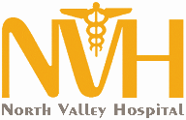 203 S. Western Ave., Tonasket WA 98855
PH: 509-486-2151 ● www.nvhospital.org

North Valley Hospital District
Strategic Planning Survey Summary 2018

Contents

Introduction: 2
Respondents: 3
Q1. Service Line Importance: 4
Q2. Greatest Challenge: 5
Q3. Strengths: 6
Q4. Weaknesses: 7
Q5. & Q6. Recommend Working at NVHD and Quality Care: 9
Q7. Financial Reality: 10
Q8. Most Important: 11
Q9. Top Three Healthcare Needs of the District: 12
Q10. Services Not Offered: 13
Q11. Obstetrics, Long-Term Care, and Emergency Department: 14
Q12. Questions and Concerns about Regional Collaboration: 15
Q13. Benefits of Collaboration 16
Q14. Trends and Developments in our Communities 17
Q15. More of, Less of, and Final Thoughts 18
Conclusion and Notes: 20

Introduction:

In October of 2018, the Board of Commissioners solicited feedback to support the Strategic Planning Process in the form of a survey.
This report will summarize, analyze, and present the valuable feedback received from the respondents. The information will be presented as fairly and accurately as possible to support the Board of Commissioners in gaining the fullest possible understanding of the responses in an effort to guide the Strategic Planning Process.
The data gathered during this survey reaffirmed the value of NVHD has a healthcare provider in North Okanogan while at the same time presenting a stark picture of the challenges facing the District. Respondents weighed in on a variety of topics including the financial viability of the Hospital, evaluating existing services, and discussing the unmet needs in our communities. Most valuably, the open-ended questions allowed respondents the opportunity to present comments or questions that provide a depth of understanding that could otherwise be missed.
Some comments from respondents in the following sections have been edited for spelling, length, or clarity. Any comment mentioning a specific Commissioner, employee, or Department has been blinded, but the full unedited comments have been shared with all Commissioners.
It is important to note this purpose of this report is to present the data from the survey but not to validate, or dispute the feelings of the respondents. Similarly, questions from the respondents will be presented in this report but left unanswered in this forum. Future communication during Board Meetings, Social Media, and Newspaper articles will tackle these questions.
The report is organized by mirroring the order of the survey questions and allows the reader to jump to a topic of interest.

Respondents:
The survey was sent via email or letter to forty leaders in the community that had been identified by the Long-Range Focus Committee. The targeted individuals were Business Leaders, Government Officials, Leaders from Education, Healthcare Partners, Non-Profit Organizations, Religious Groups, and Community Members. The survey was also distributed to all North Valley Hospital Employees, posted on the nvhospital.org website in English and Spanish, and shared publicly at the Board Meeting on October 11^{th,} 2018.
Between the survey launch date on October 16th and the close date of November 9th 135 responses were recorded. The bulk of the surveys were completed electronically, but fifteen paper copies were also received. Four surveys were completed in Spanish and the results have been translated and included. The majority of respondents came from Employees, Community Members, or from other Health Care Organizations.
Self-Identified as: | Number | Percentage
Business Leader | 6 | 5%
Community Member | 33 | 25%
Community Non-Profit | 5 | 4%
Education | 16 | 12%
Government | 5 | 4%
Healthcare Partners | 34 | 26%
Religious Organization | 4 | 3%
Staff Member | 30 | 23%
Grand Total | 133 | 100%

Q1. Service Line Importance:

The respondents were asked to rank service line according to their perceived importance as either “critical”, “very important”, “somewhat important” or “not important”.

Over 83% of respondents ranked the Emergency Department as critical, while Surgery only had 32% rank as critical. It is important to note that the services ranked as most critical do not necessarily correlate with positive financial impact to the District. For example, the ED is projected to cover its operating expenses but lose over $100,000 in 2018 after allocation of indirect expenses.

Q2. Greatest Challenge:
The respondents were asked to rank the greatest challenge facing North Valley Hospital District from a prepared list.

“Financial Stability” was targeted by 38% of respondents as the greatest challenge facing NVHD. “Availability of Providers and Clinical Services” as well as “Ability to Recruit Qualified Employees” received 23% and 16% respectively. These same concerns were frequently mentioned in a related question regarding NVHD’s biggest weaknesses.

Q3. Strengths:

In an open-ended question, respondents were asked to describe NVHD’s strengths. Three elements formed a common theme and were mentioned in the majority of the comments.
- Local: Over 57% of the comments referenced NVHD’s connection to the community, importance to the region, and the value of having services available locally.
Example Comments:
- Community support, having everything that the community needs to meet their healthcare goals in one close location.
- It is wonderful to have hospital services available to the community because transportation is an issue for people and it makes people feel comfortable to be close to home. The staff is friendly and helpful.
- Briefly: location in the North County; economic driver that brings in new dollars to our area and supports, with clinics too - 300 families that make a living wage; availability for health care locally which is very important for children and for aging parents/grandparents; a newly remodeled/updated building; professional services; and the cleanest record of all 3 hospitals - no after surgery infections for the past year.

- Employees: 43% of the comments mentioned employees, support staff, nurses, or the clinical team as the biggest strength of NVHD.
Examples Comments:
- Staff attitudes toward their community and patients - genuinely care. Collegial atmosphere.
- The strong clinical staff that represents the facility well, and provides quality health care for the valley that is very much needed. We have a great facility for such a rural location that is able to serve a small community very well if all aspects of our hospital can function well to serve them. It is a wonderful asset that we can provide obstetrical care to members of our community, and in a beautiful modern birthing wing of our hospital as well, that is something many small hospitals around us do not offer. It would serve us well to continue to attract providers that are great family medicine MD's that draw in young families, that continue to talk positively about the good experience they had at our hospital because they "loved" the provider they had when they birthed their baby here, etc.
- Staff often knows patients and their families; I believe this contributes to giving quality care.

- Quality Care: 32% mentioned the quality of the care or the approach of the providers as the biggest strength.
Example Comments:
- Good service and attention (Spanish Translation)
- Highly professional, knowledgeable and caring staff.
- The employees working the floor!

Q4. Weaknesses:

There were 111 responses to the question what is NVHD’s biggest weakness. Compared to the “strengths” questions these results had considerable variability.
Lack of Primary Care or Referrals | Administration | Financial | Retention/Recruitment | Perception, Morale, Reputation | Competency of Employees | Communication
11 | 21 | 24 | 22 | 16 | 11 | 12
10% | 19% | 22% | 20% | 14% | 10% | 11%

In this data set, interesting difference can be observed by comparing employees and healthcare works to all other respondents:

The general public views recruitment and retention (primarily of providers) as the overwhelming weakness, but internally and at other healthcare provider’s that view is not shared.
The following are example comments from each category:
Lack of Primary Care or Referrals:
- lack of primary care that supports the hospital
- Lack of referrals, hard to find upper staff (i.e., surgeon, doctors, etc.)

Administration:
- Too many administrators/managers
- There seems to be an overabundance of "Chiefs and not enough Indians."
- For whatever reason, there is a big turnover in staff. I believe this is poor management. We have good qualified people. I have never been disappointed in the care I have received but get disappointed in a new face all the time.

Financial:
- Seem always to be struggling financially to stay solvent.
- Recent high turnover in leadership positions, low compensation for services provided, i.e. Medicare, etc.,
- A small community may not have enough resources to support a full hospital

Recruitment and Retention:
- Keeping good quality people.
- Recruiting providers for surgery and in our PT departments.
- Community perceptions, recruitment of surgeons and other providers to draw more patients

Perception, Morale, Reputation:
- The community doesn't feel confident in their services, sometimes not welcomed.
- Community perception
- Bad reputation & gossip…

Competency of Employees:
- Consistent, quality, customer service
- Training for the positions, employees are uncertain, lack of confidence…
- (Lack of) Problem solving and resolution

Communication:
- Lack of communication of current problems and lack of vision communicated regarding strategic plans and organization needs.
- Communication is an area we can all work on; it helps to keep informed of changes and needs throughout the organization and this is not always effective

Q5. & Q6. Recommend Working at NVHD and Quality Care:
The next two questions are modeled after an internal survey that employee’s take quarterly to gauge morale and engagement. Past Employee Survey data is available upon request.
All Respondents | I would recommend working at NVHD to a family member or friend
Strongly Disagree | 2%
Somewhat Disagree | 3%
Neither Agree nor Disagree | 22%
Somewhat Agree | 33%
Strongly Agree | 41%
Grand Total | 100%
An interesting diversion in the data was noted for this question when comparing various subgroups of the respondents, compare employees to community members:
Employees Only | I would recommend working at NVHD to a family member or friend
Strongly Disagree | 1%
Somewhat Disagree | 0%
Neither Agree nor Disagree | 18%
Somewhat Agree | 31%
Strongly Agree | 51%
Grand Total | 100%

Community Member Only | I would recommend working at NVHD to a family member or friend
Strongly Disagree | 3%
Somewhat Disagree | 4%
Neither Agree nor Disagree | 31%
Somewhat Agree | 30%
Strongly Agree | 33%
Grand Total | 100%
82% of current employees would recommend (somewhat and strongly agree) working at NVHD but the Community member’s polled rate at only 63%. A much smaller divide can be seen for the question quality of care:
Employees Only | I believe excellent care is provided at NVHD
Strongly Disagree | 0%
Somewhat Disagree | 2%
Neither Agree nor Disagree | 9%
Somewhat Agree | 38%
Strongly Agree | 51%
Grand Total | 100%

Community Members Only | I believe excellent care is provided at NVHD
Strongly Disagree | 2%
Somewhat Disagree | 0%
Neither Agree nor Disagree | 11%
Somewhat Agree | 49%
Strongly Agree | 38%
Grand Total | 100%

Q7. Financial Reality:
The question stated “If financial reality required it would you rather”:
- Close a nonprofitable service line or department: 22 out 91 or 24%
- Consider staff reductions: 9 out 91 or 10%
- Seek community support in the form of a levy or bond: 60 out of 91 or 66%
The support for the levy or bond was the highest amongst of employees (74%), healthcare partners (67%), but less so by community members (57%).
Respondents were also offered the choice of “other” and 35 respondents filled in an option. The most common responses where:
- Reduce Administration (Salaries or Positions): 8 of 35 or 23%
- All (or multiple) of the Above: 6 of 35 or 17%
- Find efficiencies or be more productive: 4 of 35 or 11%
- Grow or develop new services: 4 of 35 or 11%

Q8. Most Important:

North Valley Hospital District plays an important role in our communities as a healthcare provider, and employer of over 200 employees, and an economic driver in North Okanogan. The respondents were asked to rate each of the elements of NVHD.
All Respondents | Healthcare Provider | Employer | Economic Driver
Least Important | 2% | 32% | 60%
Important | 9% | 59% | 27%
Most Important | 90% | 4% | 5%

The intention of this question was to separate why NVHD is valued in our communities, and the selected categories are commonly discussed as the most significant areas of impact. Survey feedback noted that some respondents felt “Employer” or “Economic Driver” as overlapping or at least lacking a clear distinction. The intention was to highlight the difference of being an employer compared to an organization that also purchased over one million dollars of supplies or services in Okanogan County.

Q9. Top Three Healthcare Needs of the District:

This question was one of the least completed questions with only 104 responses. Many of the answers were related to the needs of the District but not related to healthcare services (i.e. “better publicity”). The responses below are listed in order of occurrence for healthcare needs mentioned by respondents at least twice:
Healthcare Need | Times Mentioned
Emergency Department | 65
Long-Term Care | 27
Obstetrics | 26
Acute Care | 22
Surgery | 19
Radiology | 14
Primary Care | 14
Rehab | 8
Lab | 7
Urgent Care | 6
Ancillary | 5
Education | 4
Swing Bed | 4
Geriatrics | 4
Veteran Services | 4
Assisted Living | 3
Behavioral Health | 2
Funeral Home | 2
Oncology | 2

The highlighted responses are services not currently offered or, in the case of Veteran Services, Geriatrics, and Oncology, limited scope available, but they could be expanded. Previously, Primary Care, a VA Clinic, and the Assisted Living all were offered by NVHD but had been discontinued.

Q10. Services Not Offered:

The next question asked respondents to identify what services that were not currently being offered would most benefit the community.
Services | Times Mentioned
Behavioral Health | 8
Assisted Living | 7
Veteran Services | 7
Cardiology | 5
Dialysis | 5
Primary Care | 5
Specialist Care | 5
Oncology | 4
Podiatry | 3
Substance Abuse | 3
Urgent Care | 2
Wellness Programs | 2
Pharmacy | 2

Several service lines that are currently offered were mentioned by respondents including Physical Therapy, Orthopedic Surgery, Nursing Home, and four responses mentioned surgery or expanding surgery capabilities.
The need for better access to Behavioral Health Care has also been identified on the 2016 NVHD Community Health Needs Assessment.

Q11. Obstetrics, Long-Term Care, and Emergency Department:

Three of the most popular services offered at NVHD are unable to financially support their operations. Obstetrics, Long Term Care, and the Emergency Department. (After estimating the non-clinical expenses attributable to the service line, these service lines are projected to lose $100,000, $500,000 and $120,000, respectively, in Fiscal 2018. Q11 asked respondents to rank these services in order of their perceived importance.

Consistent with Q1 and Q8, the ED ranked overwhelming as the most important of the identified services. LTC and OB ranked roughly equal in terms of importance.

Q12. Questions and Concerns about Regional Collaboration:
Respondents were prompted with the following:
The Hospital Districts of Okanogan County have expressed the desire to find ways to work together towards a common goal of preserving access to care in the County and ensuring the viability of each Hospital.
Work on the Regional Collaboration has already begun:

Starting in August of 2018, North Valley entered into an agreement with Three Rivers Hospital in Brewster to share a CEO between the facilities. All three Hospitals have agreements in place to allow for certain employees to work at multiple locations as needed. For example, Mid Valley Hospital in Omak signed an Interlocal agreement to provide general surgical services at North Valley.
They were then asked if they had any questions or concerns about the regional collaboration. The responses were generally positive with cost savings, shared employees, and viability as top praises for the idea.
The concerns primarily related to the impact on employees, operational questions, lack of independent/autonomy, and concerns related to the Administrative teams.
The following are a few of the questions that were asked:
- Can NVHD guarantee that current employees will not lose employment due to the collaboration? What other positions/departments are currently being considered in the collaboration?
- Will it be safe for our patients or will it put them at risk due to unfamiliar work environments and overworking physicians?
- What other areas could the hospitals work together for regionalization? What about reviewing and realigning the tax districts or splitting the tax funds evenly? Centralizing surgical and OB services to one location like Omak, maybe this would help with recruiting too.
- Why wasn't this regional collaboration process started earlier?

Q13. Benefits of Collaboration

Respondents were asked to select among five options for the most important aspect of the regional collaboration:

The item most selected as “Critical” was “Improved Continuity of Care” which ranked almost as high as the next closest sections combined. This selection was led by respondents that identified as “Community Members” and “Healthcare Partners” with 67%, and 60%, of those respondents, selecting “Critical”. Conversely, this selection was not well supported among “Staff Members” with less than 30% selecting “Critical”.

Q14. Trends and Developments in our Communities
Are there particular trends and developments in our communities that we need to consider when setting NVHD’s priorities for the future?

A plurality of the respondents noted “Aging Community” as an important trend. Data from the US Census Bureau confirms that Okanogan County is older than Washington State as a whole with the median age of 43.
Population by Age | Okanogan County | Washington state
Under 5 years old | 6.2% | 6.2%
Under 18 years old | 23.0% | 22.4%
65 years and older | 20.9% | 14.8%

Given the degree to which health needs change as we age it is a fitting focus for NVHD. It was also identified on the NVHD Community Health Needs Assessment that an aging workforce was a concern for providers in our area.

Q15. More of, Less of, and Final Thoughts
The respondents were asked:
If additional future resources were available, what would you like us to consider in the future: Are there things we should do more of, less of, or differently?
The following is a selection of their comments:
- Less of: Internal Conflict and Nepotism, More of: Open Lines of communication less Voice Mail contact, Differently: Accurate billing procedures
- Build the Surgery floor, if there was a national emergency, we are in one of the safest areas--people will flock here to survive, be prepared.
- I believe if resources were available it would be wise of us to invest in our own rural health clinic again.
- Continue to become more transparent. The district has made obvious efforts over the past few years but I'd like to see the board and the leadership continue these efforts for staff and for the community. Hire smartly, not just hire someone because they are related to or know someone in the organization - spend the time to hire the right staff each time.
- RN/NAC sharing between facilities, appropriate billing/capturing more charges (and not dumped on the RNs/NACs), day care for community/staff (could bring in money and employees), cut out the wasteful positions but don't overload others because that's the biggest reason we have such a high turnover, communicating electronic charting systems (ED to AC and even between facilities)
- Investing in a collaboration with our current partners, i.e. Confluence Health for increased physician coverage in OB, surgery, etc. It could relieve the burden of existing providers and expand the future services we could provide.

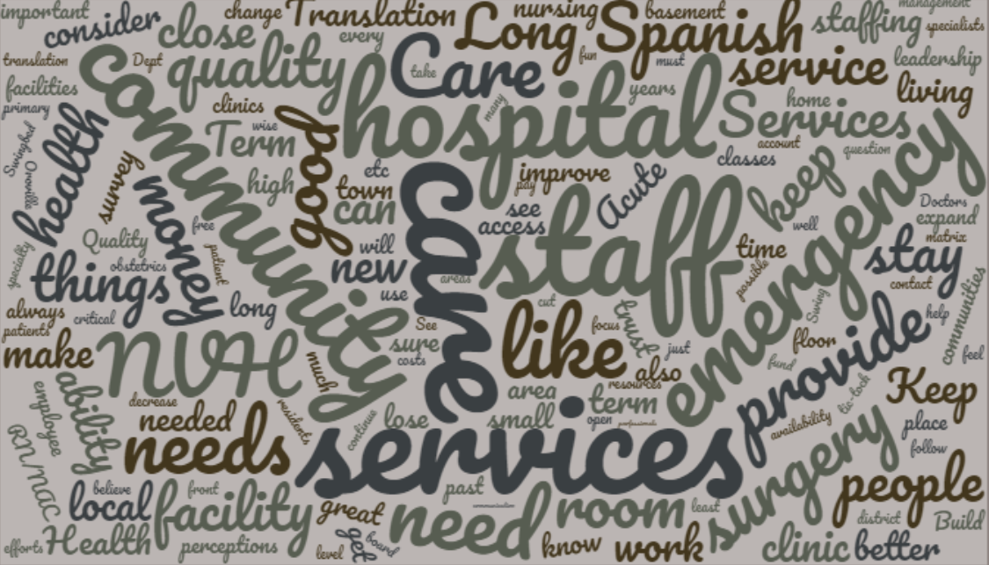
To conclude the survey respondents were asked if there was anything, they wanted the Commissioners to be aware of during the Strategic Planning Process. The following is a selection of the comments and questions:
- Plan carefully and with purpose.
- Please work towards the political process of a single payer for health care; as every other developed nation has! Health care should not be in the hands of for-profit insurance companies. Thanks for the opportunity to participate.
- Take a look at the parking lot on weekends. No cars...but NVH still runs...Too much management?
- Keeping a good staff base is important to the continued high level of care we provide for the community.
- I believe the hiring practices need to be completely re-vamped and would suggest that they be reviewed by the State Rural Hospital group to get guidance on best practices. I believe that many folks have received excessive salaries for the positions held. I am a believer in paying as much as urban areas, but know that some staff at least in the past were paid way above their level of competency.
- Short-term goals are good and necessary, but don't lose sight of the big picture or the long-term. Shortcuts are a persistent problem here and have only led to bigger losses/problems in the long run. You may have to make short-term sacrifices for long-term gains.
- It is important that we have a hospital and facility here in our local town. I don't know how you will find funding, but it is crucial to our community to get quality care and the ability to have procedures like biopsies, mammograms, surgeries, and the like here locally. Our families can't stay or go to Wenatchee every time we need a procedure. It is hard to pay for a hospital stay and motels. We need to somehow find the ability to offer those things here!
- Adding a childcare facility to the hospital district would benefit MANY!
- The direction of working with other Okanogan hospitals is brilliant. I think a bigger collaboration between the Confluence hospitals in Wenatchee and the Okanogan hospitals would also be beneficial so there isn't super pricey duplication of services.

Conclusion and Notes:

There are several recurring themes that were mentioned in various questions but failed to be summarized in any particular question but are worth noting.
Several respondents mentioned concerns about particular Departments or members of the Administrative Team. As was stated in the opening, targeted comments will not be discussed in this report but have been provided to the Administrator and the Commissioners.
The balance between frontline staff and leadership or Administration was mentioned numerous times by respondents. Given the financial situation of NVHD, all costs need to be considered carefully, particularly those not directly related to patient care. These comments align with the ongoing internal process to ensure labor costs are controlled.
The topic of NVHD operating or supporting a day-care was mentioned in this survey and employees have advocated for this in the past. It is recognized as a need in the community and would be a benefit for working parents. A lack of affordable childcare can be a major impediment for entering the workforce. NVHD is open to exploring this idea but has no plans at this time.
Finally, the Administrative Team and the Board of Commissioners would like to express our heartfelt gratitude to all of those that participated in our survey or have read this lengthy report. We strive to live our mission vision and values every day, and we appreciate your support.
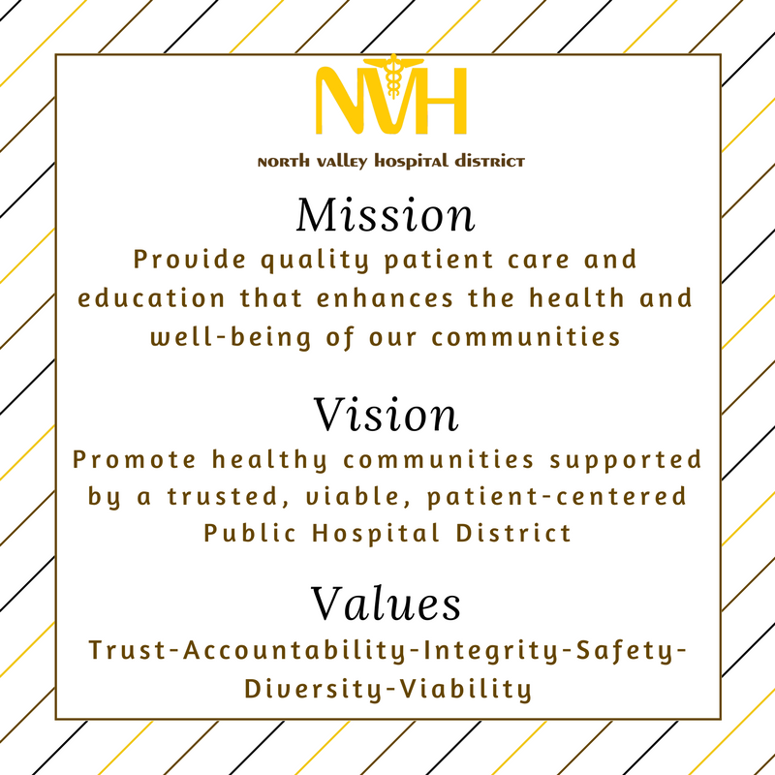

135 Respondents, but 2 did not self-identify
Internal Data Systems, Regulatory, Competitive Pressure, Clinical Technology, and Aging Population responses were not included due to low response rates.
Many comments fit more than one category, and were counted in each.
Many comments fit more than one category, and were counted in each.
Analyzing these responses required categorizing or combining similar terms and further consolidation could occur particularly with the response “Ancillary Services” which could also include “Radiology”, “Lab” and “Rehab”. Other example includes “Acute Care” as a blanket term for “inpatient” or “hospital stays”; or “Primary Care” and “Clinic” being combined.
Available at https://www.nvhospital.org/community-health-needs-assessment/
Source: US Census Bureau
Available at https://www.nvhospital.org/community-health-needs-assessment/

